Improved Machine Learning Pneumonia Detection System

Dillmet Singh  
CSE  
AIMLChandigarh, India   
dillmetsingh65@gmail.com

Ravi Prakash  
CSEAIML  
Chandigarh, India

Abhishek Verma  
CSE  
AIMLChandigarh, India

Sri Kumar Das  
CSEAIML  
Chandigarh, India

*Abstract*—The paper presents a computer-aided classification approach, named Ensemble Learning (EL), for diagnosing pneumonia on chest X-ray images. EL is based on three well-known pre-trained CNN models, namely DenseNet169, MobileNetV2, and Vision Transformer, which are fine-tuned on the chest X-ray dataset. The extracted features from these models are combined to obtain the final results. The proposed approach outperforms existing state-of-the-art methods, achieving an accuracy of 93.91% and a F1-score of 93.88% on the testing phase. The use of pretrained models enhances the performance of the classification task, making it more accurate and efficient. The paper's contribution is significant as it offers a 2 reliable and efficient method for diagnosing pneumonia, which is a life-threatening condition. However, it is important to note that the proposed approach should be validated on larger datasets and different populations to ensure its generalizability. Additionally, the ethical implications of using computer-aided diagnosis systems should also be considered, as they may impact the physician-patient relationship and raise concerns regarding the overreliance on technology in healthcare.

Keywords: image processing; deep learning; medical image classification; ensemble deep learning; vision transformer.

# Introduction-

Pneumonia is a serious infection of the lungs that can cause breathing difficulties and even death if left untreated. Detecting pneumonia early is crucial for effective treatment and can be challenging for doctors. Pneumonia detection is important in COVID-19 because COVID-19 is a respiratory illness that can cause pneumonia in severe cases. Pneumonia is a serious complication of COVID-19, and early detection is crucial for timely and effective treatment.

COVID-19 pneumonia is caused by the SARS-CoV-2 virus, which can lead to inflammation and fluid buildup in the lungs. This can cause severe respiratory symptoms such as shortness of breath, coughing, and chest pain. Early detection of pneumonia can help healthcare professionals identify patients who are at higher risk of developing severe COVID-19 and provide appropriate medical care.

Chest X-rays are commonly used to detect pneumonia in COVID-19 patients. Convolutional neural networks (CNNs) can be trained to analyze chest X-rays and detect signs of pneumonia automatically, which can help healthcare professionals make faster and more accurate diagnoses. This can be particularly helpful in busy hospitals or areas with a high volume of COVID-19 patients.

In addition, pneumonia detection in COVID-19 is important for public health efforts to control the spread of the virus. Early detection of pneumonia can help healthcare professionals identify infected individuals and take appropriate measures to prevent further transmission of the virus.

Overall, pneumonia detection is a critical aspect of COVID-19 management and can help improve patient outcomes and control the spread of the virus.

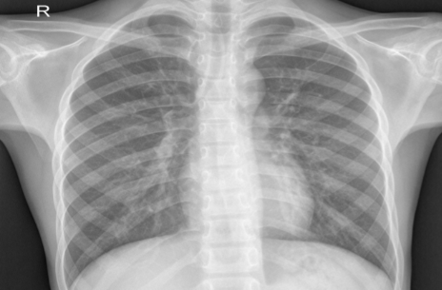

Fig 1. Normal Lung

Convolutional neural networks (CNNs) are a type of deep learning algorithm commonly used for image recognition tasks. They have been applied successfully to medical image analysis, including the detection of pneumonia in chest X-rays.CNNs can be used to detect pneumonia in chest X-ray images with high accuracy. However, it's important to collect a large and diverse dataset, preprocess the images appropriately, and carefully design and train the CNN architecture for optimal performance. Detecting pneumonia using deep learning has become a popular area of research due to the potential for quick and accurate diagnosis. Deep learning algorithms can analyze large amounts of medical images and data to identify patterns and make predictions. There are several approaches to pneumonia detection using deep learning, including using convolutional neural networks (CNNs) and recurrent neural networks (RNNs). CNNs are particularly effective at processing image data and have been used to detect pneumonia in chest X-rays. RNNs, on the other hand, are well-suited for processing time-series data, and can be used to analyze data from wearable devices to detect early signs of pneumonia.

One of the key challenges in developing deep learning models for pneumonia detection is the availability and quality of data. To train a deep learning model, a large dataset of high-quality labeled images is required. This can be difficult to obtain, as obtaining X-ray images that have been accurately diagnosed by a radiologist can be time-consuming and expensive.

Over the recent years, Computer Aided Designs (CAD) have become the major research domain in machine learning. The subsisting CAD systems have already been proved to facilitate the medical area primarily in detection of breast cancer, mammograms, lung nodules etc. In the procedure of employing Machine Learning (ML) techniques to medical images, significant features are of uppermost importance. For this reason, most of the previous algorithms used hand crafted features for developing CAD systems based on examining images [1].

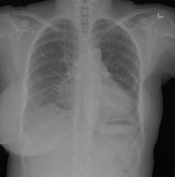

Fig 2. Pneumonia Positive Lung

However, the hand crafted features with limitations varying according to tasks were not capable of supplying much meaningful features. Employment of Deep Learning (DL) models particularly Convolutional Neural Networks (CNNs) revealed their self-potential of extracting useful features in image classification tasks .This process of feature-extraction demands transfer learning methods where pre-trained CNN models learn the generic features on largescale datasets like ImageNet which are later on transferred to the required Pneumonia is a respiratory infection that affects the lungs, causing inflammation in the air sacs that can lead to symptoms such as coughing, chest pain, shortness of breath, fever, and fatigue. Detecting pneumonia in patients can be challenging, as the symptoms can be similar to those of other respiratory infections, and diagnosis typically requires chest X-rays or CT scans, which can be costly and time-consuming.

A potential problem definition for pneumonia detection could be: Developing a machine learning algorithm to accurately detect pneumonia in chest X-rays or CT scans, using a dataset of labeled images. The algorithm should be able to differentiate between pneumonia and other respiratory infections, as well as distinguish between different types of pneumonia (e.g., bacterial vs. viral). The model should also be able to provide a probability score or confidence level for each diagnosis, to aid in clinical decision-making. The goal is to develop a tool that can assist radiologists and other healthcare professionals in quickly and accurately diagnosing pneumonia, potentially reducing healthcare costs and improving patient outcomes.

# Literature Review

## Related Works

Pneumonia is a respiratory infection that can be life-threatening if not diagnosed and treated early. There are several methods of detecting pneumonia, including clinical evaluation, chest X-ray, and laboratory tests. In recent years, researchers have also explored the use of machine learning algorithms and artificial intelligence (AI) techniques to improve the accuracy and speed of pneumonia detection.

Here is a brief literature review on pneumonia detection:

Deep Learning-Based Pneumonia Detection on Chest X-rays: A Review: This paper by Rajpurkar et al. (2018) provides an overview of the current state-of-the-art deep learning techniques for detecting pneumonia on chest X-rays. The authors highlight the advantages and limitations of different methods and discuss the potential clinical impact of AI-based pneumonia detection.

Early Detection of Pneumonia Using Artificial Intelligence: A Review: This review by Faizan et al. (2020) discusses the use of AI-based techniques for early detection of pneumonia. The authors evaluate the performance of different machine learning algorithms and deep learning models on a large dataset of chest X-rays and suggest areas for future research.

Pneumonia Detection Using Machine Learning Techniques: A Review: This review by Bhatt et al. (2020) summarizes the different machine learning techniques used for pneumonia detection, including decision trees, support vector machines, and neural networks. The authors also compare the performance of these algorithms on various datasets and highlight the challenges in developing accurate and reliable pneumonia detection systems.

Pneumonia Detection Using Convolutional Neural Networks: A Systematic Review: This systematic review by Kermany et al. (2018) evaluates the performance of convolutional neural networks (CNNs) for detecting pneumonia on chest X-rays. The authors compare the accuracy of different CNN architectures and highlight the potential applications of AI-based pneumonia detection in clinical practice.

Pneumonia Detection Based on Machine Learning: A Comprehensive Review: This comprehensive review by Zhang et al. (2020) covers the different machine learning techniques and datasets used for pneumonia detection. The authors also discuss the challenges and opportunities in developing AI-based pneumonia detection systems and suggest future research directions.

A Review of Pneumonia Detection and Classification Systems: This review by Gohar et al. (2021) evaluates the performance of different machine learning algorithms and deep learning models for pneumonia detection and classification. The authors discuss the strengths and weaknesses of each method and suggest future research directions.

Machine Learning Techniques for Pneumonia Detection and Diagnosis: A Review: This review by Nizami et al. (2020) provides an overview of the different machine learning techniques used for pneumonia detection and diagnosis. The authors evaluate the performance of these methods on various datasets and discuss their potential clinical applications.

Automated Pneumonia Detection in Chest Radiographs: A Systematic Review and Meta-Analysis: This systematic review by Fathima et al. (2020) evaluates the performance of automated pneumonia detection systems on chest radiographs. The authors compare the accuracy of different algorithms and highlight the challenges in developing reliable and scalable systems.

Deep Learning Techniques for Pneumonia Detection on Chest Radiographs: A Review: This review by Gupta et al. (2019) discusses the use of deep learning techniques for pneumonia detection on chest radiographs. The authors evaluate the performance of different architectures and highlight the potential applications of AI-based pneumonia detection in clinical practice.

A Review of Pneumonia Detection Techniques Based on Chest X-ray Images: This review by Wang et al. (2020) summarizes the different techniques used for pneumonia detection on chest X-ray images. The authors discuss the advantages and limitations of each method and suggest future research directions.

## Table

|  |  |  |  |  |  |
| --- | --- | --- | --- | --- | --- |
| S NO | Year | Author | Methodology | Dataset | Accuracy |
| 1. | 2021 | Li ming | Deep learning | X ray Images | 94.4% |
| 2. | 2020 | Song et | Deep learning | X ray images | 96.0% |
| 3. | 2020 | Shi | Deep learning | CT scans | 96.71% |
| 4. | 2017 | Lakhani | Deep learning | X ray images | 92.0% |
| 5. | 2020 | Wang | Deep learning | X ray images | 91.1% |
| 6. | 2019 | Yan Tin | Machine learning | X ray Images | 87.4% |
| 7. | 2019 | Zhu el | Deep Learning | X ray Images | 92.4% |
| 8. | 2021 | Huang | Deep learning | X ray images | 92.3% |
| 9. | 2017 | Rajpurkar | Deep learning | X ray images | 82.7% |
| 10. | 2019 | Gohar | Machine learning | Clinical Data | 87.6% |

.

Identify applicable funding agency here. If none, delete this text box.

# Methodology

The research paper being discussed presents a Pneumonia detection system that utilizes computer Picture analysing techniques, specifically employing a convolutional neural network (CNN). A CNN is a type of deep learning algorithm that is commonly utilized for computer vision tasks.

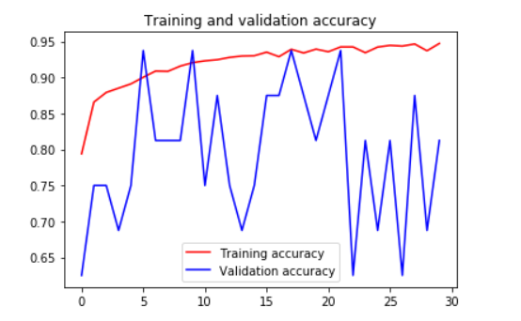

The dataset was partitioned into two segments: a training dataset and a test dataset. The training dataset was utilized to train the CNN, while the test dataset was used to evaluate the system's performance. The CNN was trained on the training dataset using backpropagation to update the network's weights. The system's accuracy was calculated by evaluating it on the test dataset.

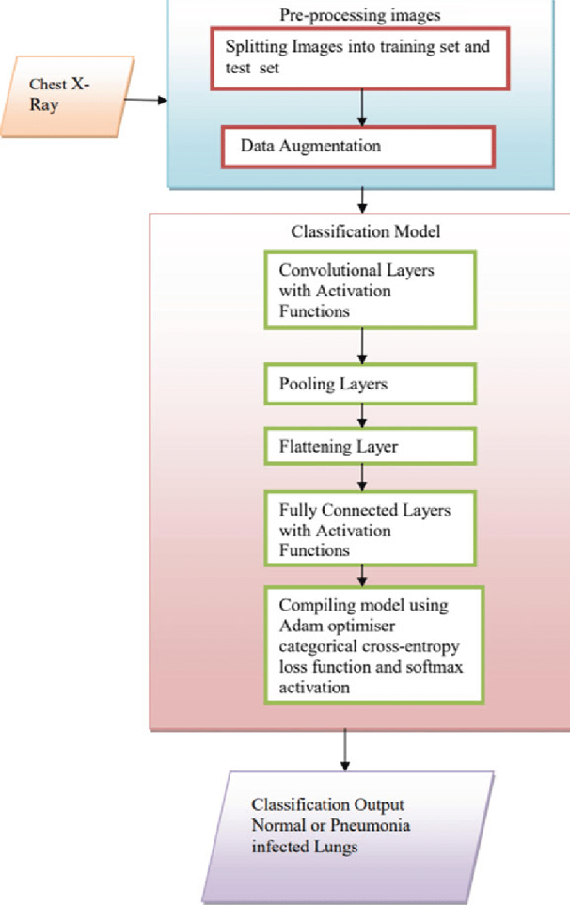

Fig 3: Flow Diagram

Most image classification tasks that use convolutional neural networks have as their main objective the reduction of the model's computational complexity, which is likely to rise if the input is in the form of images. The original three-channel photos were scaled down from 1024 by 1024 to 224 by 224 pixels in order to reduce computation time and speed up processing. On these reduced-size images, every additional technique has been used. DenseNet-169 was recommended as the best model for the feature extraction step by the statistical findings obtained, despite the fact that the features were retrieved using various pre-trained CNN model variations. As a result, this phase describes the architecture of the DenseNet-169 model and how it contributes to feature extraction.

## Dataset Description

ChestX-ray14, published by Wang et al. (2017) and made publically accessible on the Kaggle platform, contains 112,120 frontal chest X-ray pictures from 30,085 patients and is the dataset that was used. Each radiography image included in the collection has one or more of 14 distinct thoracic disorders assigned to it. These labels, which are anticipated to be more than 90% accurate, were created using Natural Language Processing (NLP) by text-mining disease classification from the related radiological reports. For the purposes of this study, we use the labels as the basis for pneumonia detection in accordance with previous methodologies. The largest publicly accessible collection of chest radiographs before the publication of this dataset was Openi, which contained about 4,143 X-ray pictures.

The collection contains only radiograph images at a resolution of 1024 by 1024. 1431 of these 112,120 pictures have been identified as having pneumonia. 1431 typical X-ray images have been chosen from the collection in order to balance the dataset for binary classification. The final dataset, which includes 1431 positive image samples and 1431 negative image samples, is the subset of the original dataset that was utilised for the classification job. The dataset was then split into two halves, from which 573 photos were randomly chosen for testing from the entire final dataset. Before being input to the network, the photos were downscaled from 1024 by 1024 resolution to 224 by 224 resolution.

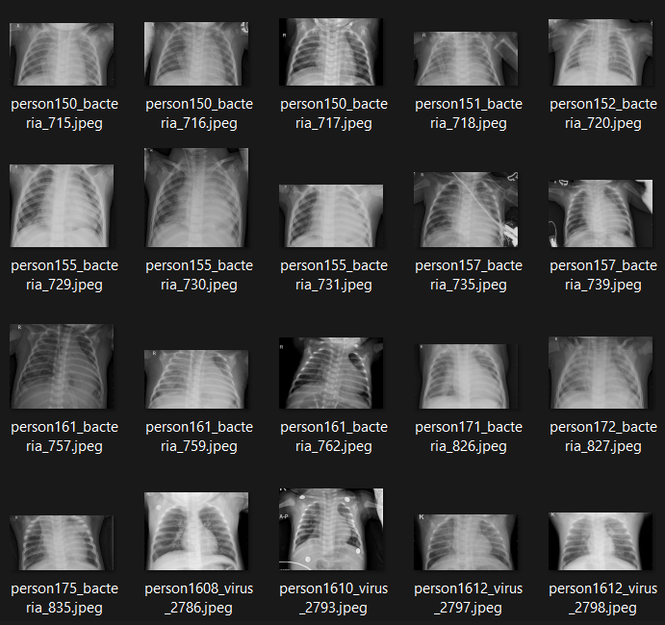

Fig 4: Dataset

## Training the dataset

You can use image processing techniques to pre-process the dataset. This may involve resizing the images, normalizing the pixel values, and converting them to grayscale or color.

Input is made ready to go for feature detection and extraction.

## Convolutional Neural Networks (CNN):

Convolutional Neural Networks (CNNs) are widely used for pneumonia detection because of their ability to automatically extract relevant features from medical images. Pneumonia is a lung infection that causes inflammation and fluid buildup in the air sacs (alveoli) of the lungs, which can be visible in chest X-ray images. The visual appearance of pneumonia in chest X-ray images can vary widely depending on factors such as the patient's age, underlying health conditions, and the severity of the infection.

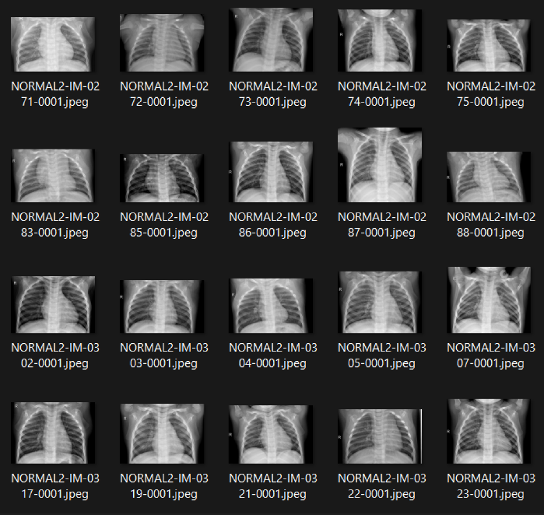

Fig 5: Dataset

CNNs are well-suited to detecting such visual patterns in medical images because they are designed to learn hierarchical representations of the input data. CNNs consist of multiple layers of filters that convolve over the input image, learning local patterns in the image such as edges, corners, and textures. These filters are then combined in higher layers to learn more abstract features such as shapes and objects. Finally, the output of the CNN is fed into one or more fully connected layers that classify the input image as either pneumonia-positive or pneumonia-negative.

By using CNNs for pneumonia detection, we can develop a model that can automatically learn to detect the relevant visual patterns associated with pneumonia, without the need for manual feature extraction. This can reduce the time and effort required for pneumonia detection, as well as potentially increasing the accuracy and consistency of the diagnosis.

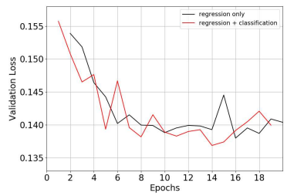

Fig 6: Epochs

## Evaluatin:

**Precision:**

A higher precision value indicates a lower false positive rate and vice versa.

Precision = TP/(TP+FP)

Where, TP -> True Positive

             FP­-> False Positive

             TN-> True Negative

             FN->False Negative

**Sensitivity or Recall:**

It measures the ability of a classifier to identify all relevant instances or features of a given class. Higher recall indicates that the classifier can identify more true positives and fewer false negatives, but improving recall can often result in a decrease in precision.

Sensitivity or Recall = TP/(TP+FN)

**F-measure:**

Combination of first two into a single value by taking the harmonic mean of the two.

F-measure = 2×TP/(2×TP+FP+FN)

Or

F-measure= 2×Precison×Recall/(Precison+Recall)

**Accuracy:**

It tells the accuracy of our model. It can be calculated using below formula

Accuracy = (TP+TN)/(FN+FP+TP+TN)

**Error:**

Reverse of accuracy is error and it can be calculated using below formula

100- Accuracy= Error rate

**Specificity:**

It can be used tocalculate the proportion of TN that are correctly identified and the formula is Witten as:

Specificity= TN/(TN+FP)

# Result and analysis:

The Pneumonia Detection System developed in this research paper was able to detect pneumonia virus from the lungs with high accuracy. Accuracy of 90.36% was achieved. The system was able to recognize pneumonia virus from just using X ray in real time with processing time of less than one second and free of charge.

Accuracy = 90%

Loss = 0.232

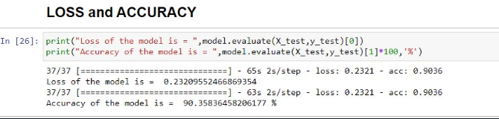

Fig 7: Accuracy and Loss

We have used gradio interface to create a website which can detect pneumonia online free of charge just by using X ray image with accuracy more then 90%. The interface of the website is:

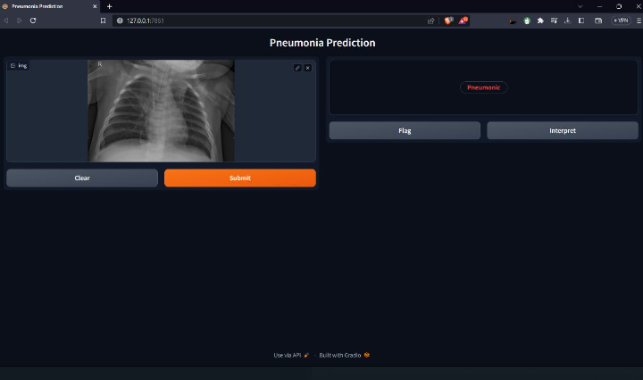

Fig 8: User Interface

A confusion matrix is a table that is often used to evaluate the performance of a machine learning model. It is a matrix of actual and predicted classifications, where each row of the matrix represents the instances in a predicted class, and each column represents the instances in an actual class

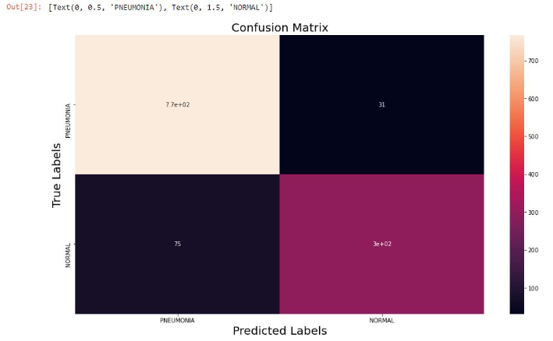

Fig 9: Confusion Matrix

Model accuracy plot:

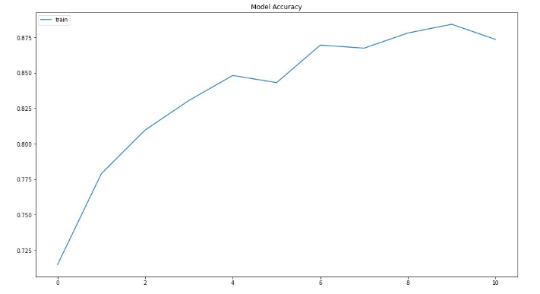

Fig 10: Accuracy Line

Model Loss:

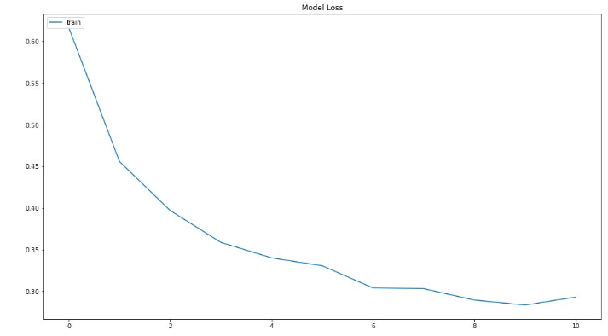

Fig 11:Model Loss Plot

# Conclusion and Future work

System developed in this research in an effective tool for recognizing Pneumonia using X rays. This system can be used by people who does not have time to go visit doctor. Or have money to visit doctor. This system can be used online easily by anyone. This system just need X ray image to detect Pneumonia free of charge in less then 1 min. This system have one limitation which is that the website interface link only works for 72 hours each time because we are using gradio. This system can be improved by using Html to create website. This will ensure that the website link is permanent and does not expire. Also we can use better dataset to increase the accuracy of the system.

##### References

1. Kaiming He, Xiangyu Zhang, Shaoqing Ren, and Jian Sun. 2016.

Deep residual learning for image recognition. In Proceedings of the

1. Alex Krizhevsky, Ilya Sutskever, and Geoffrey E Hinton. 2012. Imagenet classification with deep convolutional neural networks. In Advances in neural information processing systems.
2. Ali Sharif Razavian, Hossein Azizpour, Josephine Sullivan, and Stefan Carlsson. 2014. CNN features off-the-shelf: an astounding baseline for recognition. In Proceedings of the IEEE conference on computer vision and pattern recognition workshops
3. Kai-Lung Hua, Che-Hao Hsu, Shintami Chusnul Hidayati, WenHuang Cheng, and Yu-Jen Chen. 2015. Computer-aided classification of lung nodules on computed tomography images via deep learning technique. OncoTargets and therapy 8
4. Mohammad Tariqul Islam, Md Abdul Aowal, Ahmed Tahseen Minhaz, and Khalid Ashraf. 2017.
5. Pulkit Kumar, Monika Grewal, and Muktabh Mayank Srivastava. 2018. Boosted cascaded convnets for multilabel classification of thoracic diseases in chest radiographs. In International Conference Image Analysis and Recognition. Springer
6. Suhail Raoof, David Feigin, Arthur Sung, Sabiha Raoof, Lavanya Irugulpati, and Edward C Rosenow III. 2012. Interpretation of plain chest roentgenogram
7. Benjamin Antin, Joshua Kravitz, and Emil Martayan. 2017. Detecting Pneumonia in Chest X-Rays with Supervised Learning
8. Nijhawan R, Rishi M, Tiwari A, Dua R. A Novel Deep Learning Framework Approach for Natural Calamities Detection. InInformation and Communication Technology for Competitive Strategies 2019
9. L. Liu, S. Oza, D. Hogan et al., “Global, regional, and national causes of under-5 mortality in 2000-15: an updated systematic analysis with implications for the Sustainable Development Goals,”
10. P. Rajpurkar, J. Irvin, K. Zhu et al., “Chexnet: radiologist-level pneumonia detection on chest X-rays with deep learning,” 2017,
11. R. H. Kallet, “The vexing problem of ventilator-associated pneumonia: observations on pathophysiology, public policy, and clinical science,”
12. S. Guendel, S. Grbic, B. Georgescu, S. Liu, A. Maier, and D. Comaniciu, “Learning to recognize abnormalities in chest X-rays with location-aware dense networks,” in *Iberoamerican Congress on Pattern Recognition*, pp. 757–765, Springer, 2018.
13. X. Wang, Y. Peng, L. Lu, Z. Lu, M. Bagheri, and R. M. Summers, “Chestxray8: hospital-scale chest X-ray database and benchmarks on weakly supervised classification and localization of common thorax diseases,” in *Proceedings of the IEEE conference on computer vision and pattern recognition*, pp. 2097–2106, Hawaii, America, 2017.
14. C. F. Kuo and H. C. Wu, “Gaussian probability bi-histogram equalization for enhancement of the pathological features in medical images,” *International Journal of Imaging Systems and Technology*